18CS2056 – Mobile Application Development

**URK17CS145**

using Android Lab

|  |  |
| --- | --- |
| **Ex. No. 9** | **Sending Greetings using SMS with OTP Login** |
| **Date of Exercise** | 29/10/20 |
| **Google drive Link** | <https://drive.google.com/drive/u/1/folders/1Tc2t-ueiFg0xqGNkzrSnKjMBQXc1itNW> |

# Aim

## To create an application to send sms with OTP login using java in

android studio. **Program MainActivity.java**

**package** com.example.birthdaywish;

**import** androidx.annotation.NonNull;

**import** androidx.appcompat.app.AlertDialog; **import** androidx.appcompat.app.AppCompatActivity; **import** androidx.core.app.ActivityCompat;

**import** androidx.core.content.ContextCompat;

**import** android.Manifest;

**import** android.content.Context;

**import** android.content.Intent;

**import** android.content.pm.PackageManager;

**import** android.database.Cursor;

**import** android.os.Build;

**import** android.os.Bundle;

**import** android.provider.ContactsContract; **import** android.telephony.SmsManager; **import** android.view.View;

**import** android.widget.Adapter; **import** android.widget.ArrayAdapter; **import** android.widget.Button; **import** android.widget.ListView; **import** android.widget.TextView; **import** android.widget.Toast;

**import** java.util.ArrayList;

**import** java.util.Random;

**public class** MainActivity **extends** AppCompatActivity { Button **loginbt**,**sendotpbt**;

TextView **mobilenumber**,**otpbox**;

1

18CS2056 – Mobile Application Development

**URK17CS145**

using Android Lab

**final int SEND_SMS_CODE**=1; String **otp**;

@Override

**protected void** onCreate(Bundle savedInstanceState) { **super**.onCreate(savedInstanceState); setContentView(R.layout.***activity_main***); **loginbt**=findViewById(R.id.***loginid***); **sendotpbt**=findViewById(R.id.***sendotpid***); **mobilenumber**=findViewById(R.id.***mobilenumberid***); **otpbox**=findViewById(R.id.***otpid***);

**final** Random random=**new** Random(); ActivityCompat.*requestPermissions*(MainActivity.**this**,**new**

String[]{Manifest.permission.***READ_CONTACTS***,Manifest.permission.***SEND_SMS***},**SEND_SMS_CODE**)

;

**sendotpbt**.setOnClickListener(**new** View.OnClickListener() { @Override

**public void** onClick(View view) {

String number=**mobilenumber**.getText().toString(); **int** iotp=1000+random.nextInt(9999); **otp**=String.*valueOf*(iotp); **if**(checkpermission(Manifest.permission.***SEND_SMS***)){

SmsManager smsManager=SmsManager.*getDefault*(); smsManager.sendTextMessage(number,**null**,**"Your OTP for BirthdayWish**

**is "**+String.*valueOf*(iotp),**null**,**null**);

**final** AlertDialog.Builder builder = **new**

AlertDialog.Builder(MainActivity.**this**);

builder.setMessage(**"OTP Sent"**); builder.show();

}

**else** {

**final** AlertDialog.Builder builder = **new**

AlertDialog.Builder(MainActivity.**this**);

builder.setMessage(**"Permission not set"**); builder.show();

}

}

});

**loginbt**.setOnClickListener(**new** View.OnClickListener() { @Override

**public void** onClick(View view) {

String otp2=**otpbox**.getText().toString();

**if**(otp2.equals(**otp**)){

Intent intent=**new** Intent(MainActivity.**this**,SendWish.**class**); startActivity(intent);

}

**else**

{

**final** AlertDialog.Builder builder = **new**

AlertDialog.Builder(MainActivity.**this**);

builder.setMessage(**"Incorrect OTP\nTry again!"**); builder.show();

}

}

});

2

18CS2056 – Mobile Application Development

**URK17CS145**

using Android Lab

}

**public boolean** checkpermission(String permission)

{

**int** check= ContextCompat.*checkSelfPermission*(**this**,permission);

**return** (check==PackageManager.***PERMISSION_GRANTED***);

}

}

# Activity_main.xml

*<?***xml version="1.0" encoding="utf-8"***?>*

<**LinearLayout xmlns:android="**[**http://schemas.android.com/apk/res/android**](http://schemas.android.com/apk/res/android)**" xmlns:app="**[**http://schemas.android.com/apk/res-auto**](http://schemas.android.com/apk/res-auto)**" xmlns:tools="**[**http://schemas.android.com/tools**](http://schemas.android.com/tools)**" android:layout_width="match_parent" android:layout_height="match_parent"**

**tools:context=".MainActivity" android:orientation="vertical"**>

<**TextView**

**android:layout_width="wrap_content" android:layout_height="wrap_content" android:text="Welcome to Birthday Greeting" android:layout_gravity="center" style="@style/TextAppearance.AppCompat.Body2" android:textSize="30dp" android:textColor="#ff00ff"**/>

<**TextView**

**android:layout_marginTop="20dp" android:layout_width="wrap_content" android:layout_height="wrap_content" android:text="OTP Login" android:layout_gravity="center" style="@style/TextAppearance.AppCompat.Body2" android:textSize="30dp" android:textColor="#ff00ff"**/>

<**EditText**

**android:layout_marginLeft="50dp" android:layout_marginRight="50dp" android:layout_marginTop="50dp" android:layout_width="match_parent" android:layout_height="40dp" android:textColorHint="#0000ff" android:hint="Your Mobile Number" android:id="@+id/mobilenumberid"**/>

<**Button**

**android:layout_width="wrap_content" android:layout_height="wrap_content" android:text="Get otp" android:layout_marginTop="20dp" android:id="@+id/sendotpid" android:layout_gravity="center"**/>

3

18CS2056 – Mobile Application Development

**URK17CS145**

using Android Lab

<**EditText**

**android:layout_marginLeft="50dp" android:layout_marginRight="50dp" android:layout_marginTop="50dp" android:layout_width="match_parent" android:layout_height="40dp" android:hint="OTP" android:id="@+id/otpid" android:textColorHint="#0000ff"**/>

<**Button**

**android:layout_width="wrap_content" android:layout_height="wrap_content" android:layout_marginTop="20dp" android:text="Login" android:id="@+id/loginid" android:layout_gravity="center"**/>

</**LinearLayout**>

# Sendwish.java

**package** com.example.birthdaywish;

**import** androidx.annotation.NonNull;

**import** androidx.appcompat.app.AlertDialog; **import** androidx.appcompat.app.AppCompatActivity; **import** androidx.core.content.ContextCompat;

**import** android.Manifest;

**import** android.content.pm.PackageManager;

**import** android.database.Cursor;

**import** android.os.Build;

**import** android.os.Bundle;

**import** android.provider.ContactsContract; **import** android.telephony.SmsManager; **import** android.view.View;

**import** android.widget.AdapterView; **import** android.widget.ArrayAdapter; **import** android.widget.Button; **import** android.widget.ListView; **import** android.widget.TextView; **import** android.widget.Toast;

**import** java.util.ArrayList;

**public class** SendWish **extends** AppCompatActivity { Button **getcontact**,**sendbt**;

TextView **SMSnumber**,**SMSmessage**; ListView **contactlist**; ArrayList<String> **arrayList**; ArrayAdapter<String> **arrayAdapter**; String[] **number**;

@Override

4

**protected void** onCreate(Bundle savedInstanceState) { **super**.onCreate(savedInstanceState); setContentView(R.layout.***activity_send_wish***); **sendbt**=findViewById(R.id.***sendidionsend***); **SMSmessage**=findViewById(R.id.***messageidonsend***); **contactlist** = findViewById(R.id.***contactlist***); **arrayList** = **new** ArrayList<>();

**getcontact** = findViewById(R.id.***selectcontactsid***); **SMSnumber**=findViewById(R.id.***mobilenumberidonsend***); **contactlist**.setOnItemClickListener(**new** AdapterView.OnItemClickListener() {

@Override

**public void** onItemClick(AdapterView<?> adapterView, View view, **int** i, **long**

l) {

}

});

String temp=**arrayAdapter**.getItem(i); **number**=temp.split(**":"**); **SMSnumber**.setText(**number**[2].replace(**" "**,**""**));

**getcontact**.setOnClickListener(**new** View.OnClickListener() { @Override

**public void** onClick(View view) {

**if** (Build.VERSION.***SDK_INT*** >= Build.VERSION_CODES.***M*** &&

checkSelfPermission(Manifest.permission.***READ_CONTACTS***) != PackageManager.***PERMISSION_GRANTED***) {

requestPermissions(**new** String[]{Manifest.permission.***READ_CONTACTS***},

1);

} **else** {

getcontacts();

}

18CS2056 – Mobile Application Development

**URK17CS145**

using Android Lab

}

**public void** getcontacts() { Cursor cursor =

getContentResolver().query(ContactsContract.CommonDataKinds.Phone.***CONTENT_URI***, **null**,

ContactsContract.Contacts.***HAS_PHONE_NUMBER*** + **" = 1"**, **null**,

**"UPPER("** + ContactsContract.Contacts.***DISPLAY_NAME*** + **") ASC"**); **while** (cursor.moveToNext()) {

String name = cursor.getString(cursor.getColumnIndex(ContactsContract.CommonDataKinds.Phone.***DISPLAY_ NAME***));

String number = cursor.getString(cursor.getColumnIndex(ContactsContract.CommonDataKinds.Phone.***NUMBER***));

**arrayList**.add(**"Name: "** + name + **"\n"** + **"Number: "** + number);

}

**arrayAdapter** = **new** ArrayAdapter(SendWish.**this**, android.R.layout.***simple_list_item_1***, **arrayList**);

**contactlist**.setAdapter(**arrayAdapter**);

}

**public void** onRequestPermissionsResult(**int** requestCode, @NonNull String[] permissions, @NonNull **int**[] grantResults) {

**if** (requestCode == 1) {

5

18CS2056 – Mobile Application Development

**URK17CS145**

using Android Lab

**if** (grantResults[0] == PackageManager.***PERMISSION_GRANTED***) { getcontacts();

}

} **else** {

Toast.*makeText*(SendWish.**this**, **"Need Your Permission!"**,

Toast.***LENGTH_LONG***);

}

}

});

**sendbt**.setOnClickListener(**new** View.OnClickListener() { @Override

**public void** onClick(View view) {

String msg=**SMSmessage**.getText().toString();

**if**(checkpermission(Manifest.permission.***SEND_SMS***)){ SmsManager smsManager=SmsManager.*getDefault*();

smsManager.sendTextMessage(**SMSnumber**.getText().toString(),**null**,**"Wishes for you!\n"**+msg,**null**,**null**);

**final** AlertDialog.Builder builder = **new**

AlertDialog.Builder(SendWish.**this**);

builder.setMessage(**"Message Sent"**); builder.show();

}

**else** {

**final** AlertDialog.Builder builder = **new**

AlertDialog.Builder(SendWish.**this**);

builder.setMessage(**"Permission not set"**); builder.show();

}

}

});

}

**public boolean** checkpermission(String permission)

{

**int** check= ContextCompat.*checkSelfPermission*(**this**,permission);

**return** (check==PackageManager.***PERMISSION_GRANTED***);

}

}

# Acticity_Sendwish.xml

*<?***xml version="1.0" encoding="utf-8"***?>*

<**LinearLayout xmlns:android="**[**http://schemas.android.com/apk/res/android**](http://schemas.android.com/apk/res/android)**" xmlns:app="**[**http://schemas.android.com/apk/res-auto**](http://schemas.android.com/apk/res-auto)**" xmlns:tools="**[**http://schemas.android.com/tools**](http://schemas.android.com/tools)**" android:layout_width="match_parent" android:layout_height="match_parent"**

**tools:context=".SendWish" android:orientation="vertical"**>

<**TextView**

6

18CS2056 – Mobile Application Development

**URK17CS145**

using Android Lab

**android:layout_width="wrap_content" android:layout_height="wrap_content" android:text="Send Birthday Greeting" android:layout_gravity="center" style="@style/TextAppearance.AppCompat.Body2" android:textSize="30dp" android:textColor="#ff00ff"**/>

<**EditText**

**android:layout_width="match_parent" android:layout_height="40dp" android:hint="Enter Mobile Number" android:layout_marginLeft="50dp" android:layout_marginRight="50dp" android:layout_marginTop="50dp" android:textColorHint="#0000ff" android:id="@+id/mobilenumberidonsend"**/>

<**TextView**

**android:layout_marginTop="20dp" android:layout_width="wrap_content" android:layout_height="wrap_content" android:text="OR" android:layout_gravity="center" style="@style/TextAppearance.AppCompat.Body2" android:textSize="30dp" android:textColor="#ff00ff"**/>

<**Button**

**android:layout_width="wrap_content" android:layout_height="wrap_content" android:text="Select contact number" android:layout_marginTop="20dp" android:layout_gravity="center" android:id="@+id/selectcontactsid"**

/>

<**EditText**

**android:layout_width="match_parent" android:textColorHint="#0000ff" android:layout_height="40dp" android:hint="Enter your message" android:layout_marginLeft="50dp" android:layout_marginRight="50dp" android:layout_marginTop="50dp" android:id="@+id/messageidonsend"**/>

<**Button**

**android:layout_width="wrap_content" android:layout_height="wrap_content" android:text="Send" android:layout_marginTop="20dp" android:layout_gravity="center" android:id="@+id/sendidionsend" android:layout_marginBottom="20dp"**

/>

<**ListView**

**android:layout_width="match_parent"**

7

18CS2056 – Mobile Application Development

**URK17CS145**

using Android Lab

**android:layout_height="match_parent" android:id="@+id/contactlist" android:layout_marginRight="20dp" android:layout_marginLeft="20dp"**

/>

</**LinearLayout**>

# Output Screenshots

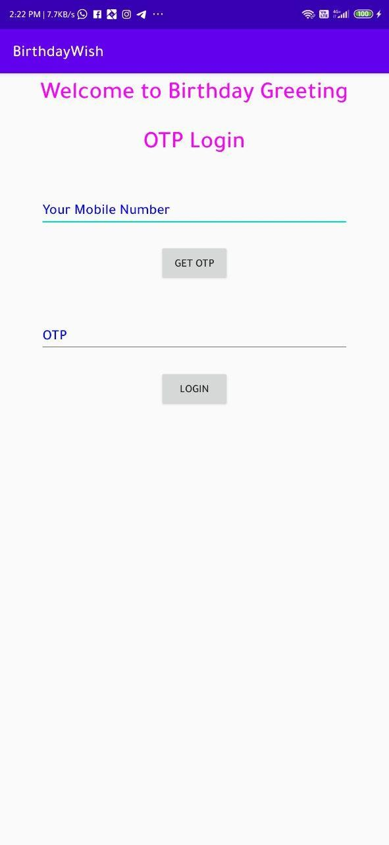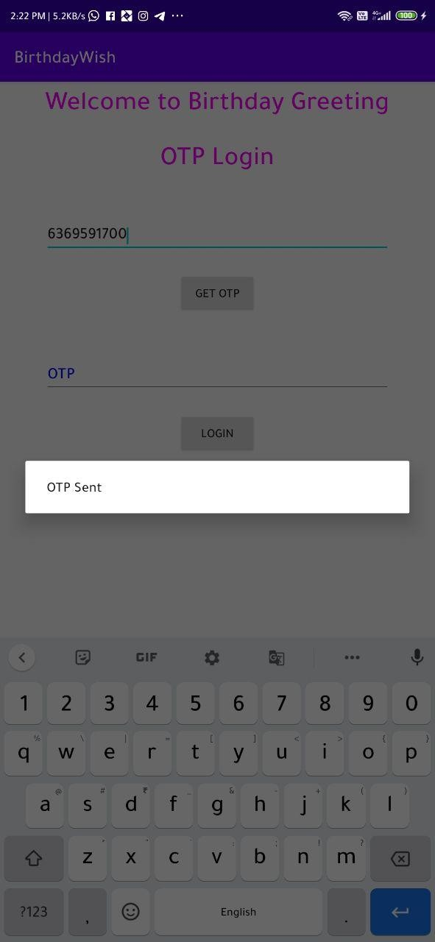

8

18CS2056 – Mobile Application Development

**URK17CS145**

using Android Lab

9

18CS2056 – Mobile Application Development

**URK17CS145**

using Android Lab

**Result**

## The application to send sms with OTP login was created using java in android studio and successfully installed on device.

10